Welcome To
Trinity Lutheran Church
Lutheran Church—Missouri Synod
A Stephen Ministry Congregation

1354 South Otsego Avenue
Gaylord, Michigan 49735
Church Phone: (989) 732-4816

Church Email: secretary@trinitygaylord.com
www.trinitygaylord.com

Office Hours: Monday through Friday 9am – 1pm

OUR PURPOSE
…is to LOVE GOD, LOVE OTHERS, AND SERVE THE WORLD by worshiping the Lord Jesus, bringing our members into Christ-like maturity, and equipping them through Word and Sacrament for their mission and ministry. We go heart to heart into the world with Jesus, sharing His love, caring for one another, praying, and bringing the lost into a relationship with Christ, by the working of the Holy Spirit.

November 6, 2022
All Saints Day
Preacher: Rev. Paul Schneider

ABOUT OUR WORSHIP
We welcome all who gather here today! We are blessed to celebrate together the mercy, grace, and love we have from God through the death and resurrection of our Lord Jesus Christ.

Children: Families with children are very welcome here. Having children in church is important so they can begin to learn about their faith in Jesus, and it’s good for the whole congregation to see. Please feel comfortable keeping “squirmy” kids in the service. This is where they belong, too!

Pew Cards: Guests and Members, please fill out the Guest/Member card located on the back of the pew in front of you and pass it to the end of the aisle. If you forget you can put it in the offering plate on your way out.

If standing is difficult: Please feel free to remain seated during any portion of the service. Please let an Elder or Usher know if you need communion in your pew seat.

About our celebration of Holy Communion: We celebrate the Lord’s Supper in the confession and glad confidence that, as he says, our Lord gives into our mouths not only bread and wine but his very body and blood to eat and to drink for the forgiveness of sins and to strengthen our union with him and with one another. Our Lord invites to his table those who trust his words, repent of all sin, and set aside any refusal to forgive and love as he forgives and loves us, that they may show forth his death until he comes.
Because those who eat and drink our Lord’s body and blood contrary to that which is stated above do so to their great harm, and also because Holy Communion is a confession of the faith which is confessed at this altar. Anyone who is not yet instructed, in doubt, or who hold a confession differing from that of the Lutheran Church—Missouri Synod, and yet desire to receive the sacrament, are asked first to speak with Pastor. Those not communing are still invited to come forward for a blessing from Pastor, and you may indicate this by crossing your arms over your chest.
TTTTTT
GREETING
P Peace be with you.
C And also with you.
P Let up Pray.
T ORDER OF SERVICE T
(The liturgy is from Divine Service Setting four LSB pg. 203ff)

OPENING HYMN
Jerusalem the Golden LSB 672 Stand on st. 4
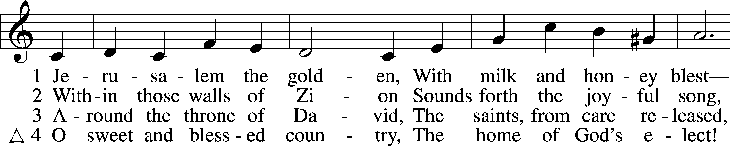
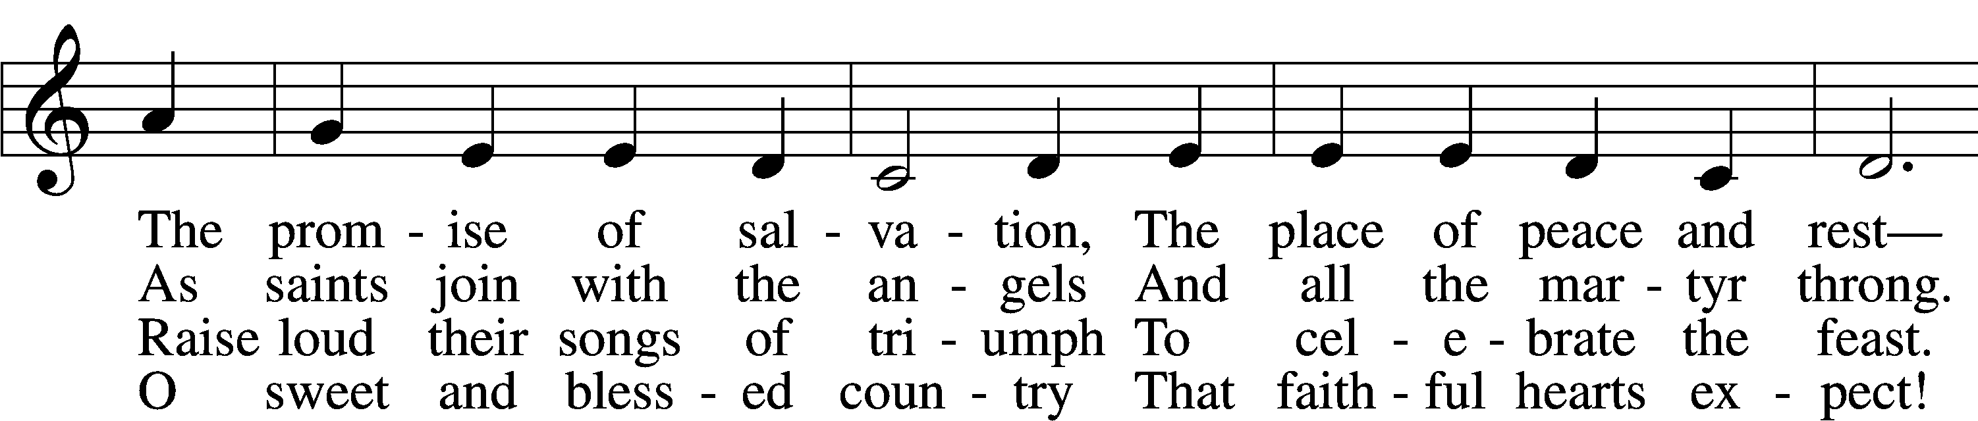
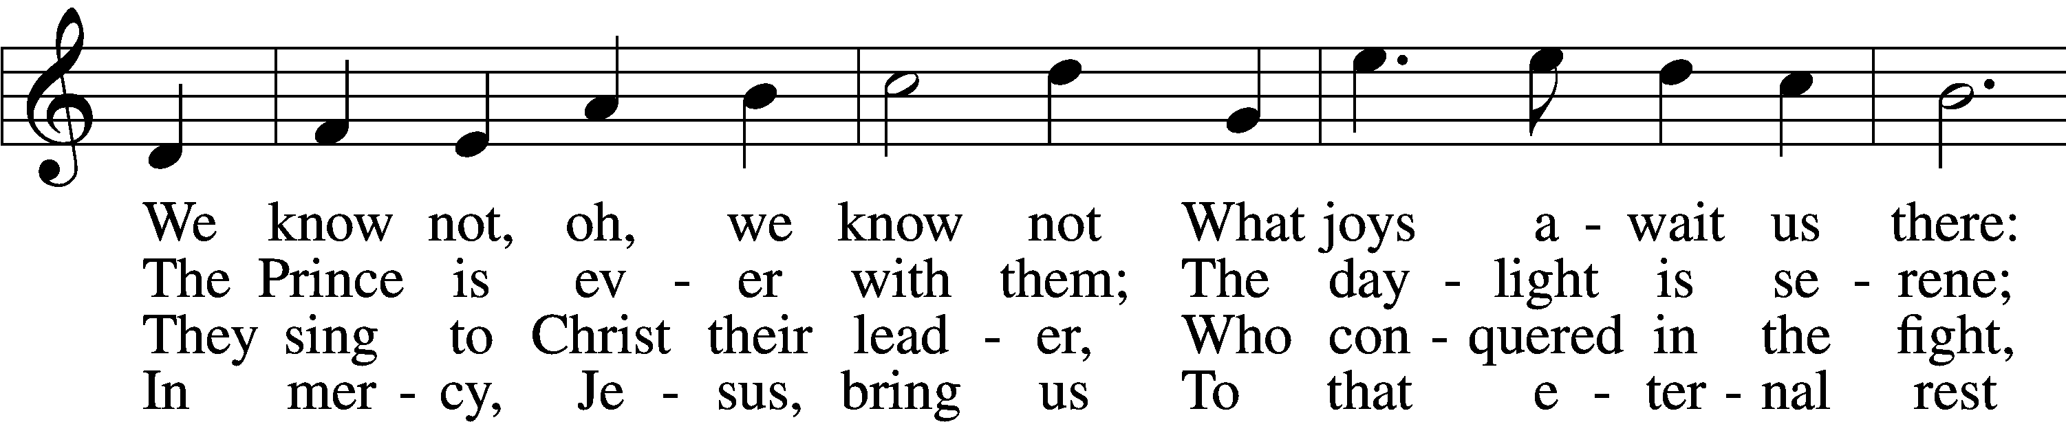
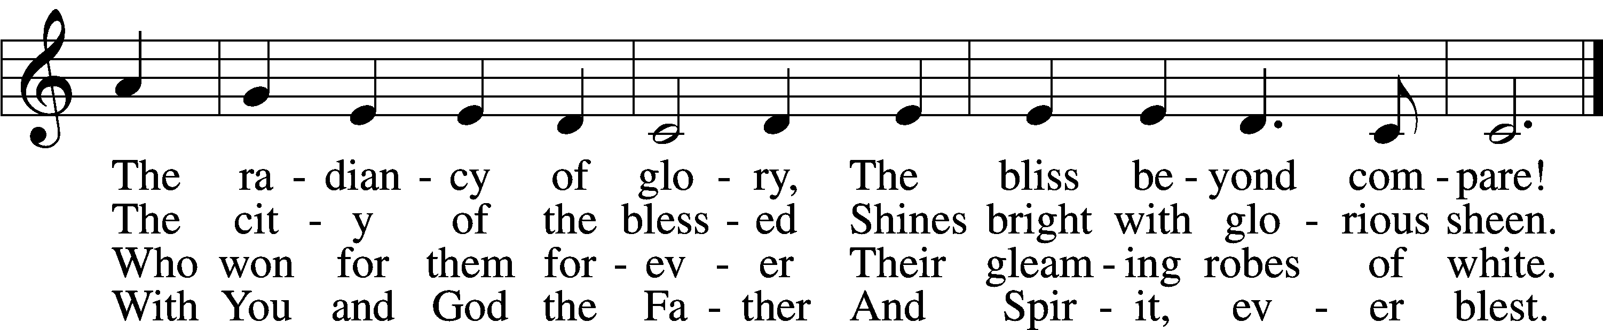

Please stand as able

CONFESSION and ABSOLUTION
The sign of the cross may be made by all in remembrance of their Baptism.

P In the name of the Father and of the T Son and of the Holy Spirit.
C Amen.
P Our help is in the name of the Lord,
C who made heaven and earth.

P If You, O Lord, kept a record of sins, O Lord, who could stand?
C But with You there is forgiveness; therefore You are feared.

P Since we are gathered to hear God’s Word, call upon Him in prayer and praise, and receive the body and blood of our Lord Jesus Christ in the fellowship of this altar, let us first consider our unworthiness and confess before God and one another that we have sinned in thought, word, and deed, and that we cannot free ourselves from our sinful condition. Together as His people let us take refuge in the infinite mercy of God, our heavenly Father, seeking His grace for the sake of Christ, and saying: God, be merciful to me, a sinner.
C Almighty God, have mercy upon us, forgive us our sins, and lead us to everlasting life. Amen.

P Almighty God in His mercy has given His Son to die for you and for His sake forgives you all your sins. As a called and ordained servant of Christ, and by His authority, I therefore forgive you all your sins in the name of the Father and of the T Son and of the Holy Spirit.
C Amen.

T SERVICE OF THE WORD T
KYRIE LSB 204
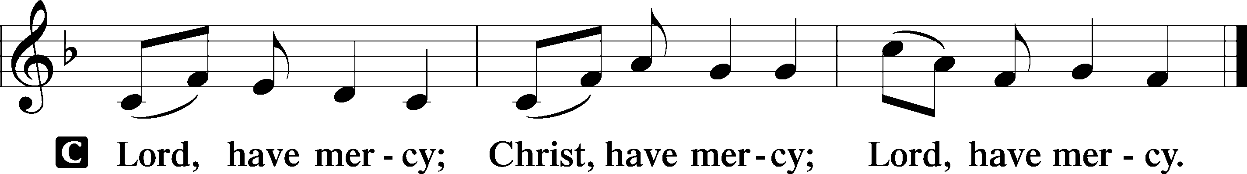

HYMN OF PRAISE
From All That Dwell Below the Skies LSB 816 stand on sts.3
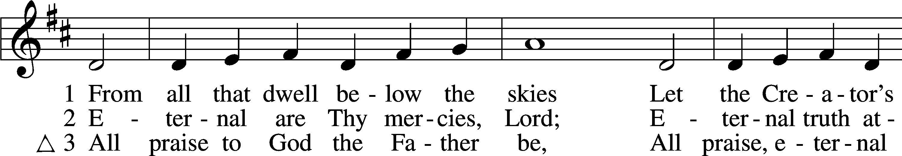
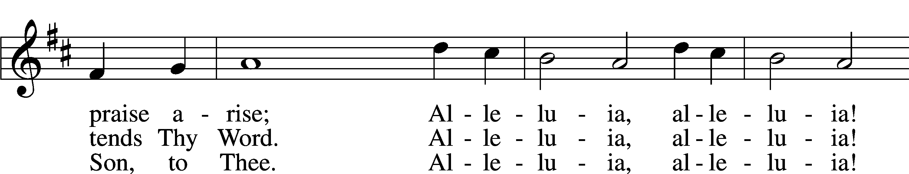
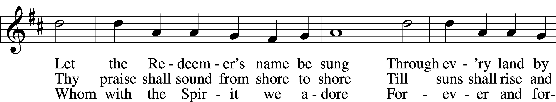
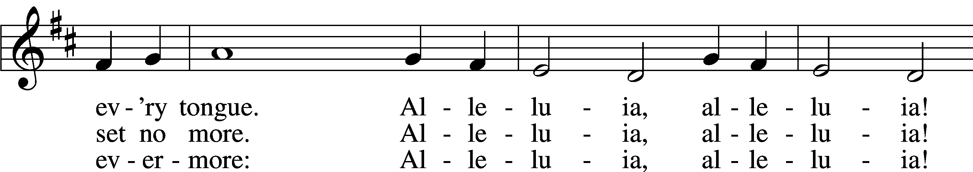
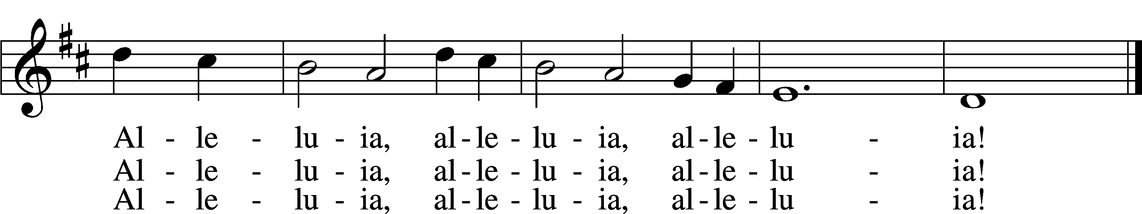

SALUTATION AND COLLECT OF THE DAY
P The Lord be with you.
C And also with you.

P Let us pray.
Living God, Your almighty power is made known chiefly in showing mercy and pity. Grant us the fullness of Your grace to lay hold of Your promises and live forever in Your presence; through Jesus Christ, Your Son, our Lord, who lives and reigns with You and the Holy Spirit, one God, now and forever.
C Amen.

Please be seated
FIRST READING Psalm 149
¹Praise the Lord!
Sing to the Lord a new song,
his praise in the assembly of the godly!
²Let Israel be glad in his Maker;
let the children of Zion rejoice in their King!
³Let them praise his name with dancing,
making melody to him with tambourine and lyre!
⁴For the Lord takes pleasure in his people;
he adorns the humble with salvation.
⁵Let the godly exult in glory;
let them sing for joy on their beds.
⁶Let the high praises of God be in their throats
and two-edged swords in their hands,
⁷to execute vengeance on the nations
and punishments on the peoples,
⁸to bind their kings with chains
and their nobles with fetters of iron,
⁹to execute on them the judgment written!
This is honor for all his godly ones. Praise the Lord!

CHOIR ANTHEM We’re a Fellowship of Believers

EPISTLE 1 John 3:1–3
¹See what kind of love the Father has given to us, that we should be called children of God; and so we are. The reason why the world does not know us is that it did not know him. ²Beloved, we are God’s children now, and what we will be has not yet appeared; but we know that when he appears we shall be like him, because we shall see him as he is. ³And everyone who thus hopes in him purifies himself as he is pure.
P This is the Word of the Lord.
C Thanks be to God.
Please stand as able
ALLELUIA AND VERSE
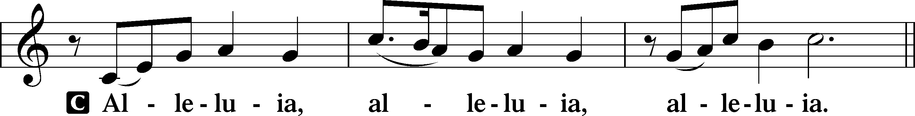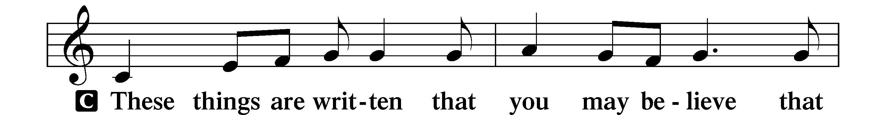
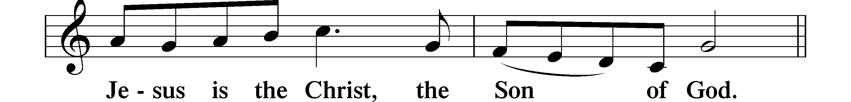
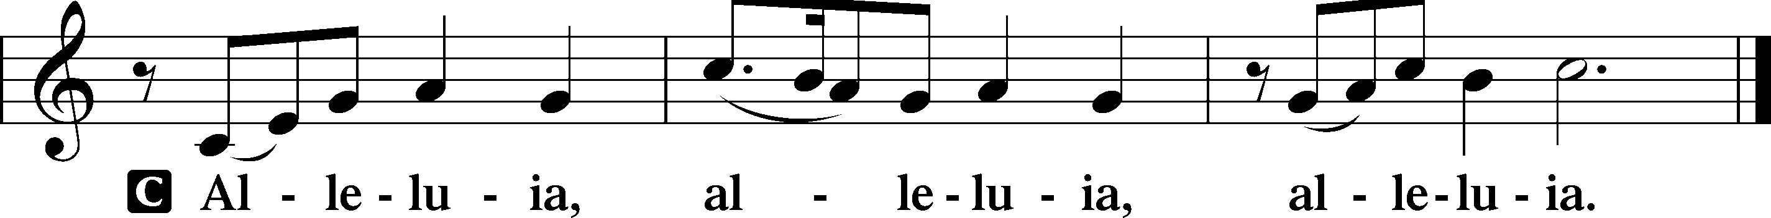

HOLY GOSPEL Matthew 5:1–12
P The Holy Gospel according to St. Matthew, the fifth chapter.
C Glory to You, O Lord.

¹Seeing the crowds, [Jesus] went up on the mountain, and when he sat down, his disciples came to him.
²And he opened his mouth and taught them, saying:
³“Blessed are the poor in spirit, for theirs is the kingdom of heaven.
⁴“Blessed are those who mourn, for they shall be comforted.
⁵“Blessed are the meek, for they shall inherit the earth.
⁶“Blessed are those who hunger and thirst for righteousness, for they shall be satisfied.
⁷“Blessed are the merciful, for they shall receive mercy.
⁸“Blessed are the pure in heart, for they shall see God.
⁹“Blessed are the peacemakers, for they shall be called sons of God.
¹⁰“Blessed are those who are persecuted for righteousness’ sake, for theirs is the
kingdom of heaven.
¹¹“Blessed are you when others revile you and persecute you and utter all kinds of evil
against you falsely on my account. ¹²Rejoice and be glad, for your reward is great in heaven, for so they persecuted the prophets who were before you.”
P This is the Gospel of the Lord.
C Praise to You, O Christ.

NICENE CREED
C I believe in one God,
the Father Almighty,
maker of heaven and earth
and of all things visible and invisible.
And in one Lord Jesus Christ,
the only-begotten Son of God,
begotten of His Father before all worlds,
God of God, Light of Light,
very God of very God,
begotten, not made,
being of one substance with the Father,
by whom all things were made;
who for us men and for our salvation came down from heaven
and was incarnate by the Holy Spirit of the virgin Mary
and was made man;
and was crucified also for us under Pontius Pilate.
He suffered and was buried.
And the third day He rose again according to the Scriptures
and ascended into heaven
and sits at the right hand of the Father.
And He will come again with glory to judge both the living and the dead,
whose kingdom will have no end.
And I believe in the Holy Spirit,
the Lord and giver of life,
who proceeds from the Father and the Son,
who with the Father and the Son together is worshiped and glorified,
who spoke by the prophets.
And I believe in one holy Christian and apostolic Church,
I acknowledge one Baptism for the remission of sins,
and I look for the resurrection of the dead
and the life T of the world to come. Amen.
Please be seated

ALL GOD’S CHILDREN – TALK

PRE-SERMON HYMN
For All the Saints LSB 677 sts. 1–4
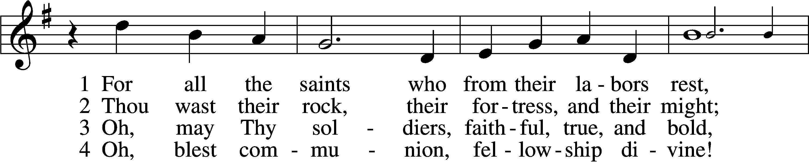
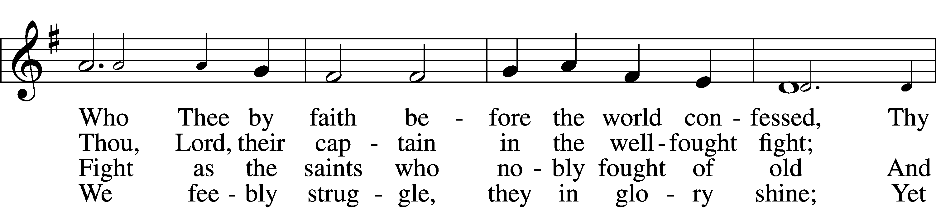
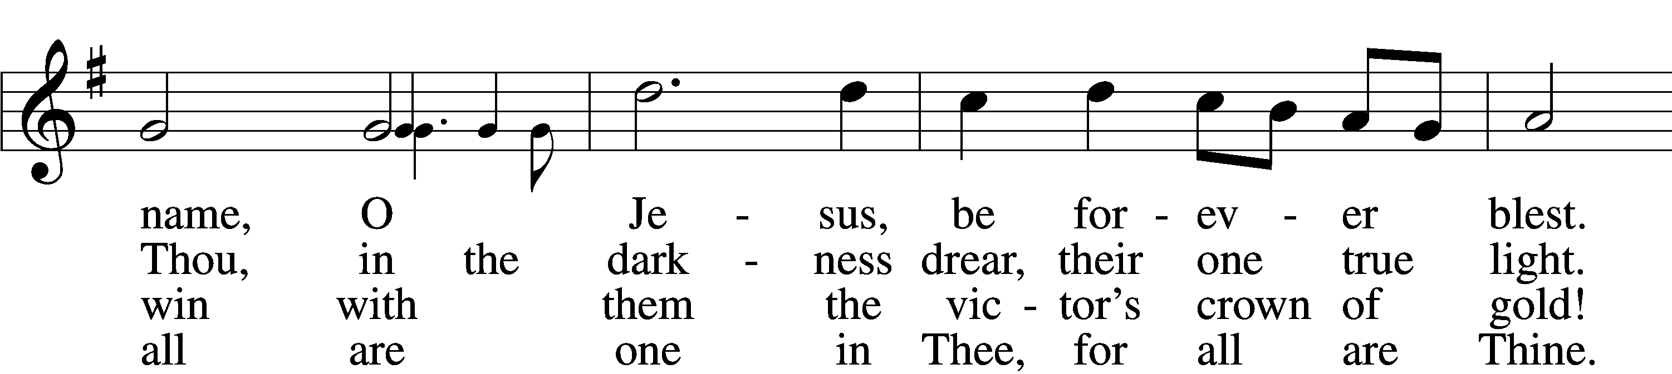
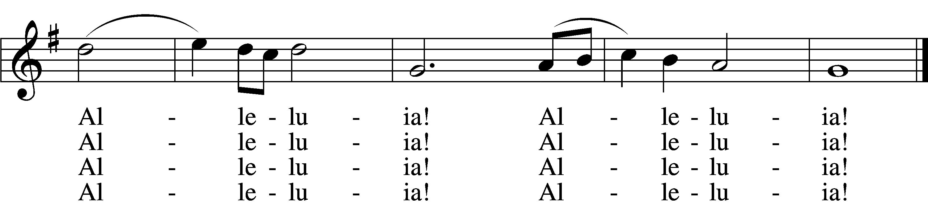

SERMON

POST-SERMON HYMN
For All the Saints LSB 677 sts. 5–8
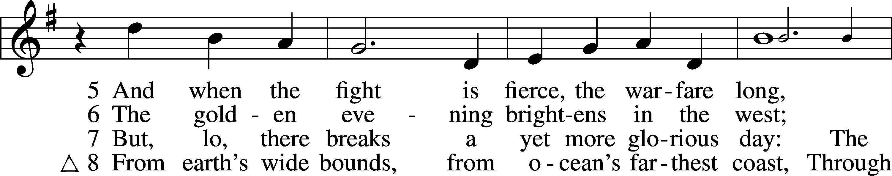
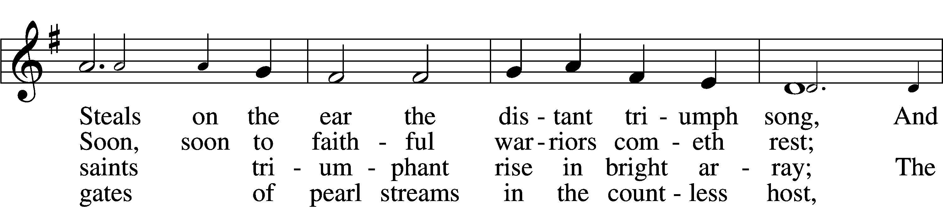
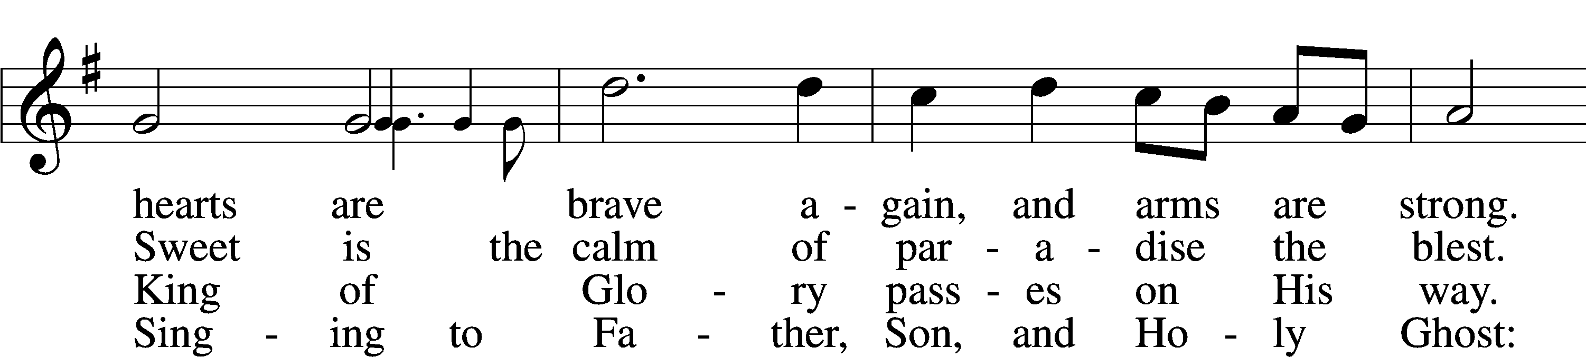
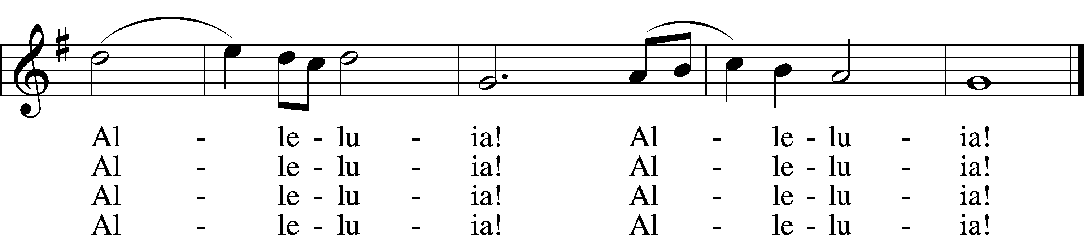

Please stand as able

REMEMBRANCE OF THE FAITHFUL DEPARTED
We remember those who have finished their course in faith in the past year, who now rest from their labors with the Lord and are on our hearts and minds. The sound of a bell will be heard following each name spoken.

Richard Sherman
Robert Breen
Violet Erat
June Weber
Karen Christoff
Ruth Luebs
Vilma Ward
Dolores Mouch
Hilda Koch

PRAYER of the CHURCH
After each Segment:
P Lord, in Your Mercy,
C Hear our Prayer.
After Final Segment:
P Hear us as we pray in His name and as He has taught us:
LORD’S PRAYER
C Our Father who art in heaven,
hallowed be Thy name,
Thy kingdom come,
Thy will be done on earth
as it is in heaven;
give us this day our daily bread;
and forgive us our trespasses
as we forgive those
who trespass against us;
and lead us not into temptation,
but deliver us from evil.
For Thine is the kingdom
and the power and the glory
forever and ever. Amen.
T SERVICE of the SACRAMENT T

PREFACE LSB 208
P The Lord be with you.
C And also with you.

P Lift up your hearts.
C We lift them to the Lord.

P Let us give thanks to the Lord our God.
C It is right to give Him thanks and praise.

P It is truly good, right, and salutary that we should at all times and in all places give thanks to You, O Lord, holy Father, almighty and everlasting God, for the countless blessings You so freely bestow on us and all creation. Above all, we give thanks for Your boundless love shown to us when You sent Your only-begotten Son, Jesus Christ, into our flesh and laid on Him our sin, giving Him into death that we might not die eternally. Because He is now risen from the dead and lives and reigns to all eternity, all who believe in Him will overcome sin and death and will rise again to new life. Therefore with angels and archangels and with all the company of heaven we laud and magnify Your glorious name, evermore praising You and singing:

SANCTUS LSB 208
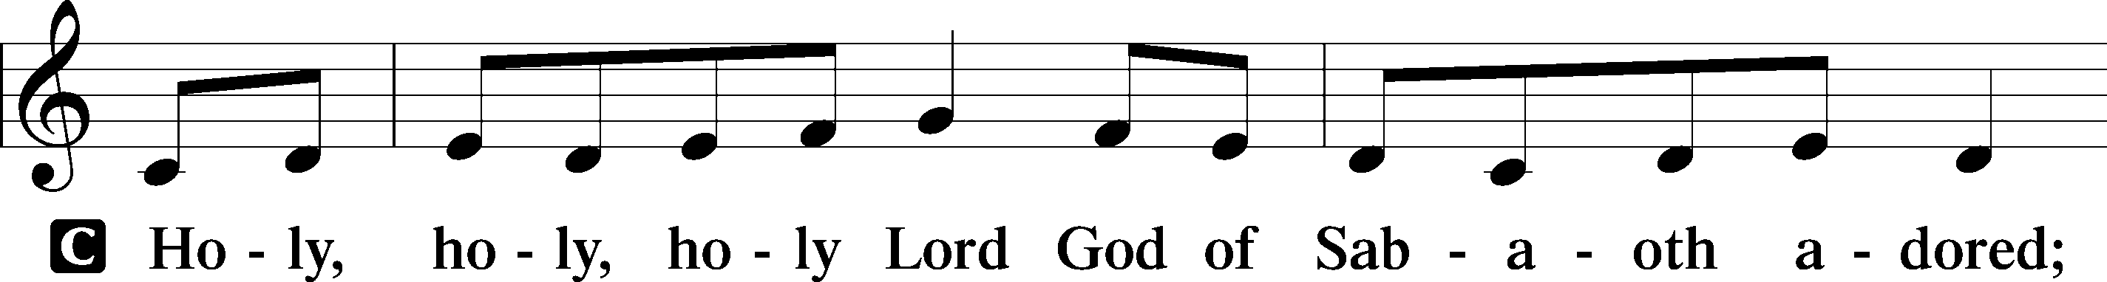
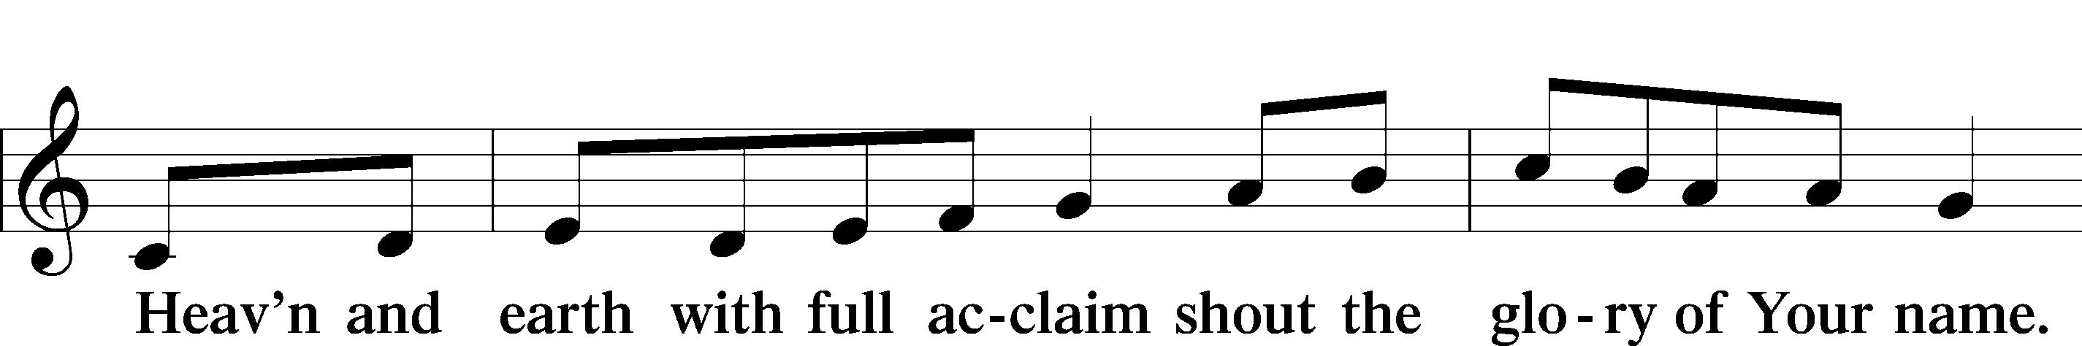
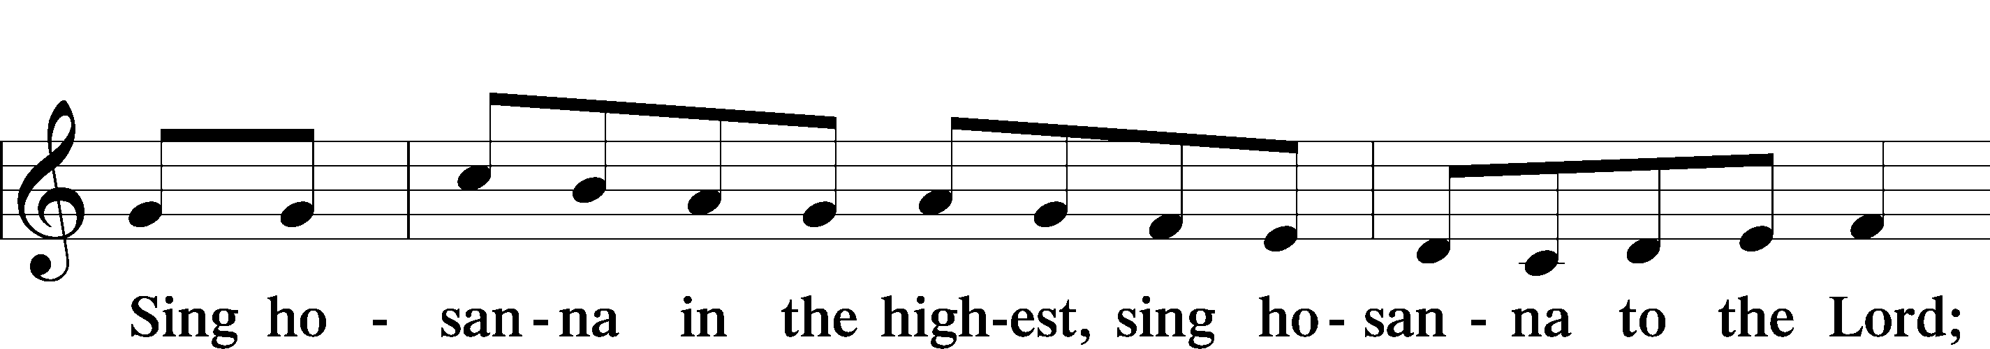

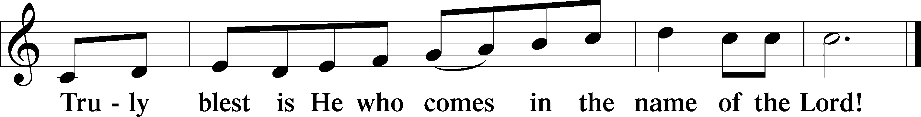
THE WORDS OF OUR LORD
P Our Lord Jesus Christ, on the night when He was betrayed, took bread, and when He had given thanks, He broke it and gave it to the disciples and said: “Take, eat; this is My T body, which is given for you. This do in remembrance of Me.”
In the same way also, He took the cup after supper, and when He had given thanks, He gave it to them, saying: “Drink of it, all of you; this cup is the New Testament in My T blood, which is shed for you for the forgiveness of sins. This do, as often as you drink it, in remembrance of Me.”

PAX DOMINI
P The peace of the Lord be with you always.
C Amen.
AGNUS DEI
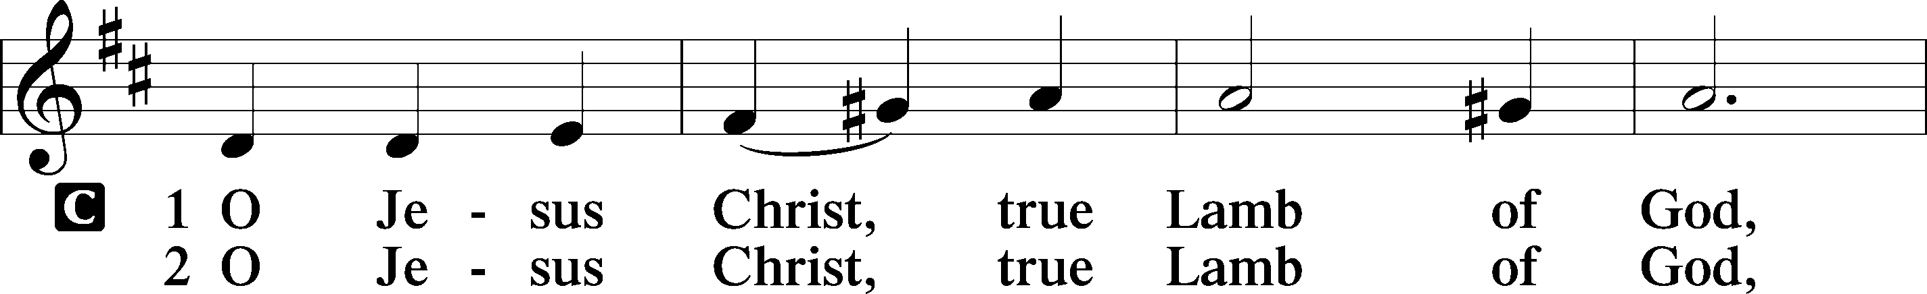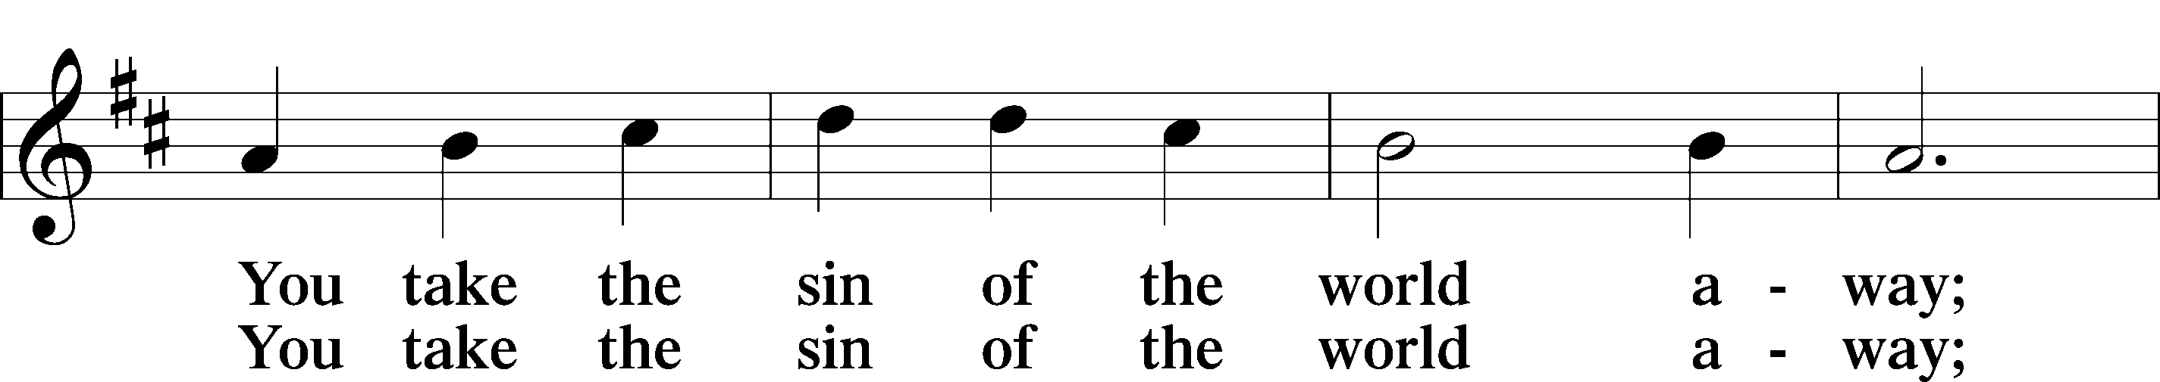
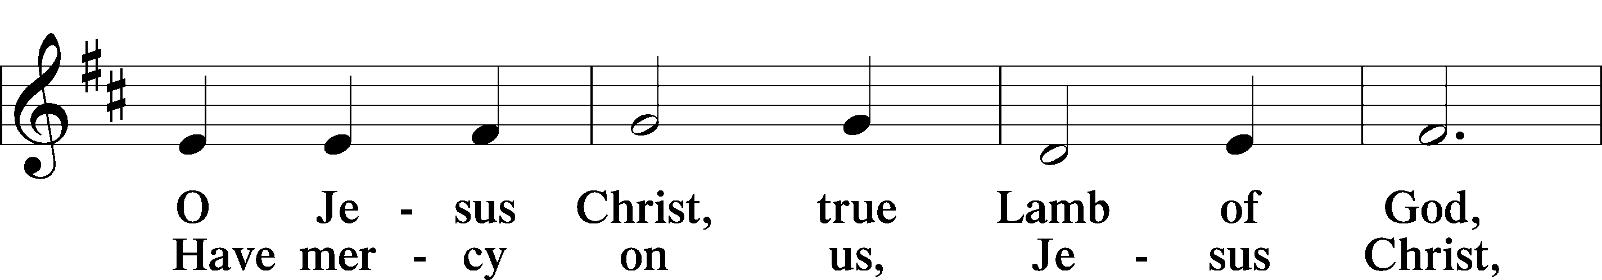
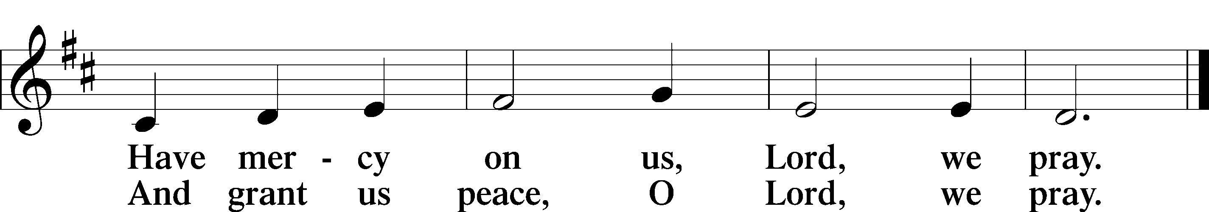

Please be seated
DISTRIBUTION
The pastor and those who assist him receive the body and blood of Christ first, then Communion will be served at the rail. Ushers will help direct you forward via the center aisle; please return to your seats via the side aisles. Gluten-free bread is available for those who need it, as is non-alcoholic grape juice. Simply request either when you come forward to receive Communion.
DISTRIBUTION HYMN
Jesus Comes Today with Healing LSB 620
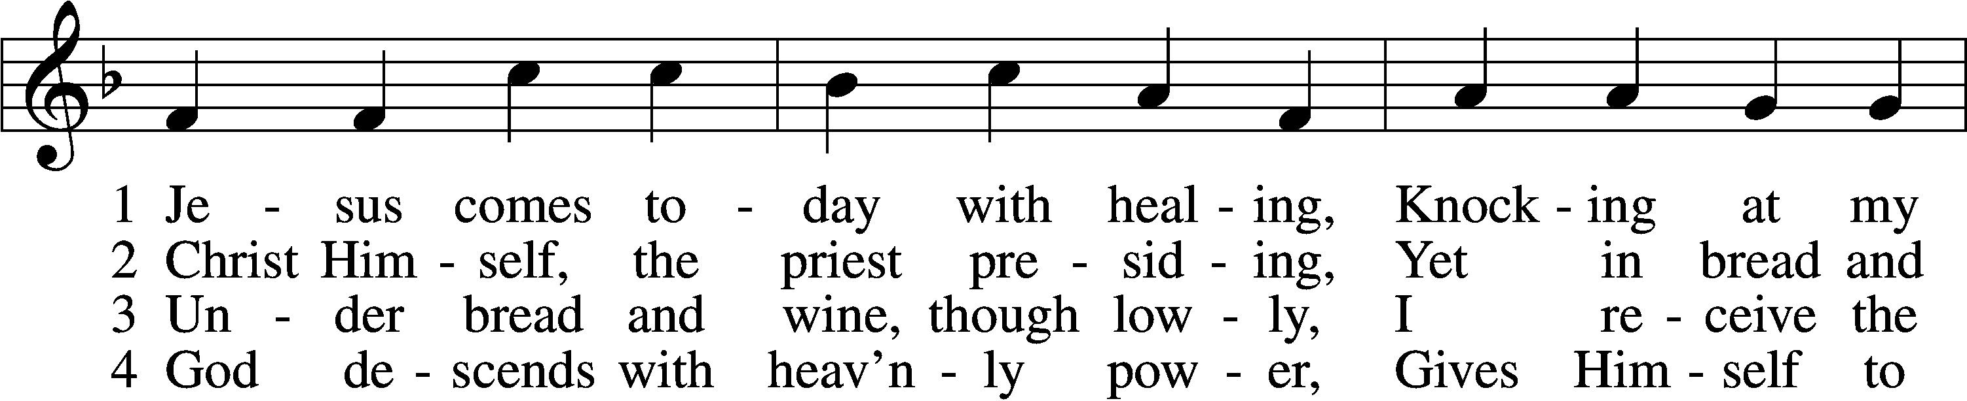
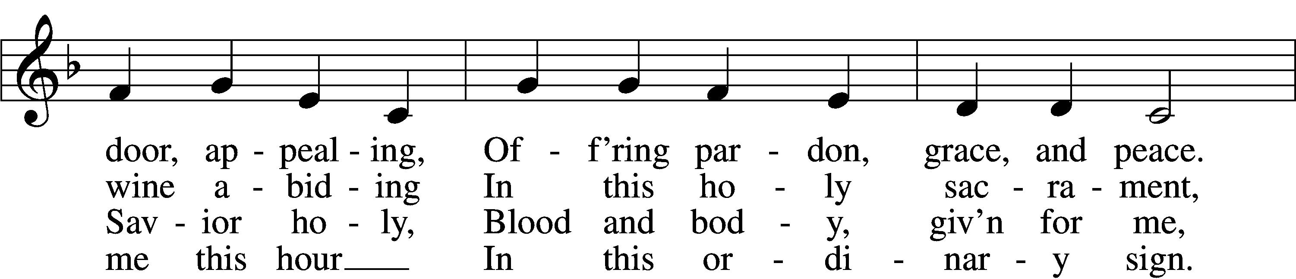
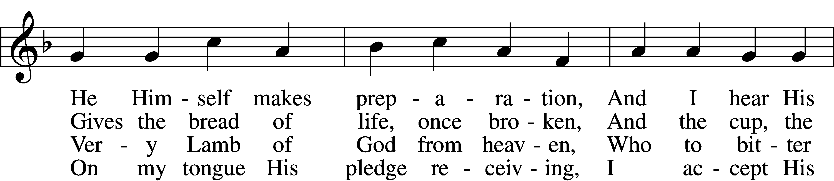
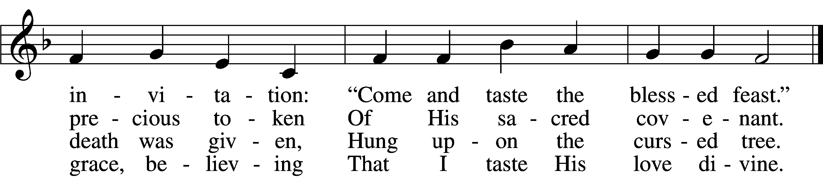

5 Let me praise God’s boundless favor,
Whose own feast of love I savor,
Bidden by His gracious call.
Wedding garments He provides me,
With a robe of white He hides me,
Fits me for the royal hall.
6 Now have I found consolation,
Comfort in my tribulation,
Balm to heal the troubled soul.
God, my shield from ev’ry terror,
Cleanses me from sin and error,
Makes my wounded spirit whole.

DISTRIBUTION HYMN
At the Lamb’s High Feast We Sing LSB 633 Please stand on st. 8
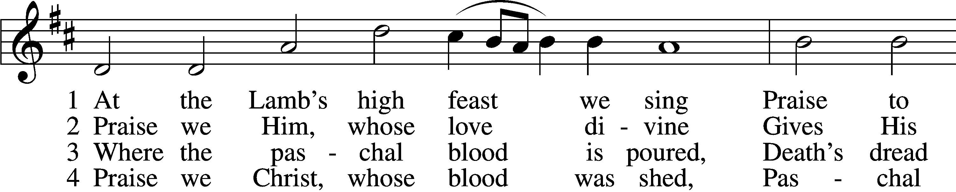
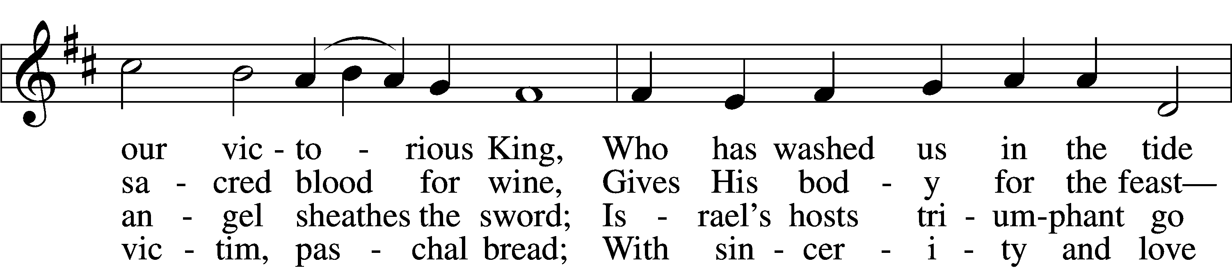
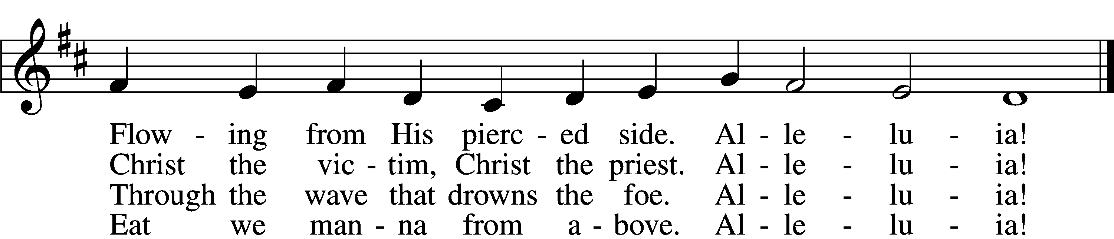
\

5 Mighty Victim from the sky,
Hell’s fierce pow’rs beneath You lie;
You have conquered in the fight,
You have brought us life and light.
Alleluia!

6 Now no more can death appall,
Now no more the grave enthrall;
You have opened paradise,
And Your saints in You shall rise.
Alleluia!

7 Easter triumph, Easter joy!
This alone can sin destroy;
From sin’s pow’r, Lord, set us free,
Newborn souls in You to be.
Alleluia!

8 Father, who the crown shall give,
Savior, by whose death we live,
Spirit, guide through all our days:
Three in One, Your name we praise.
Alleluia!
Please stand as able

NUNC DIMITTIS LSB 211
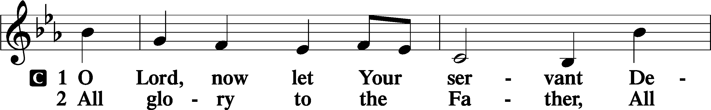
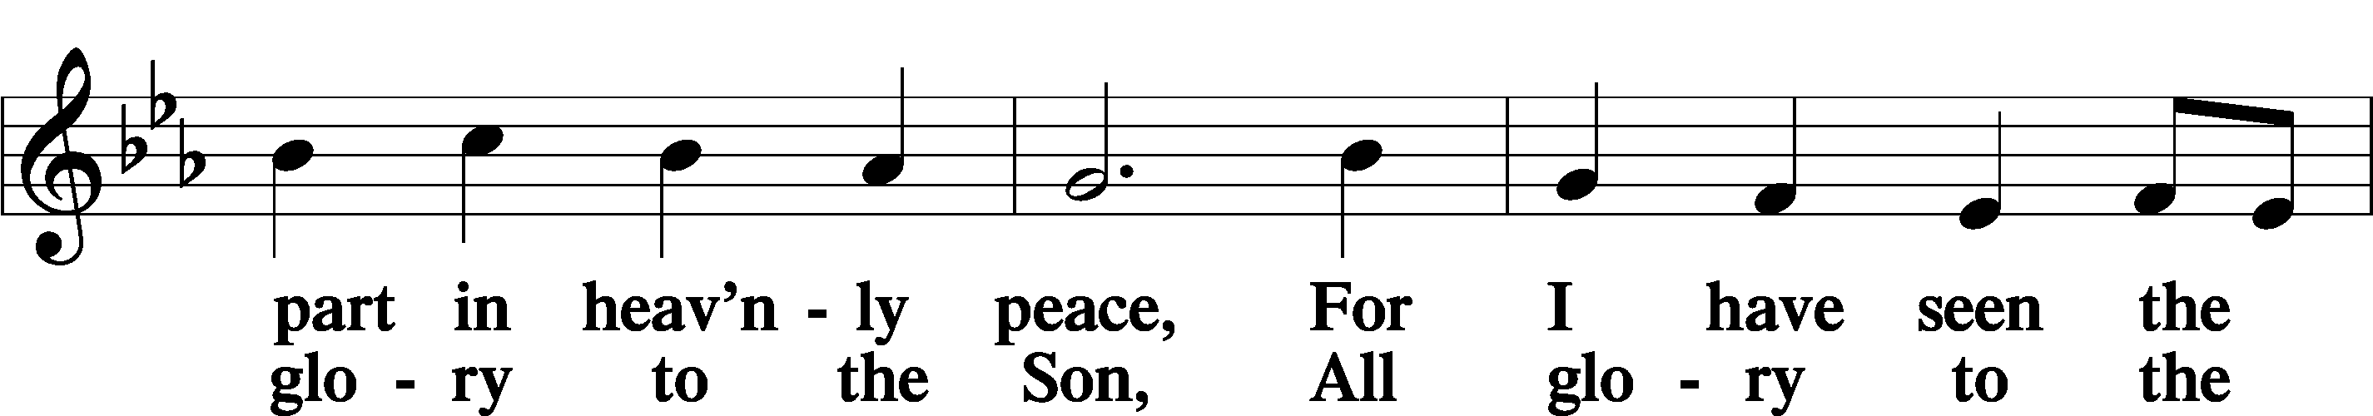
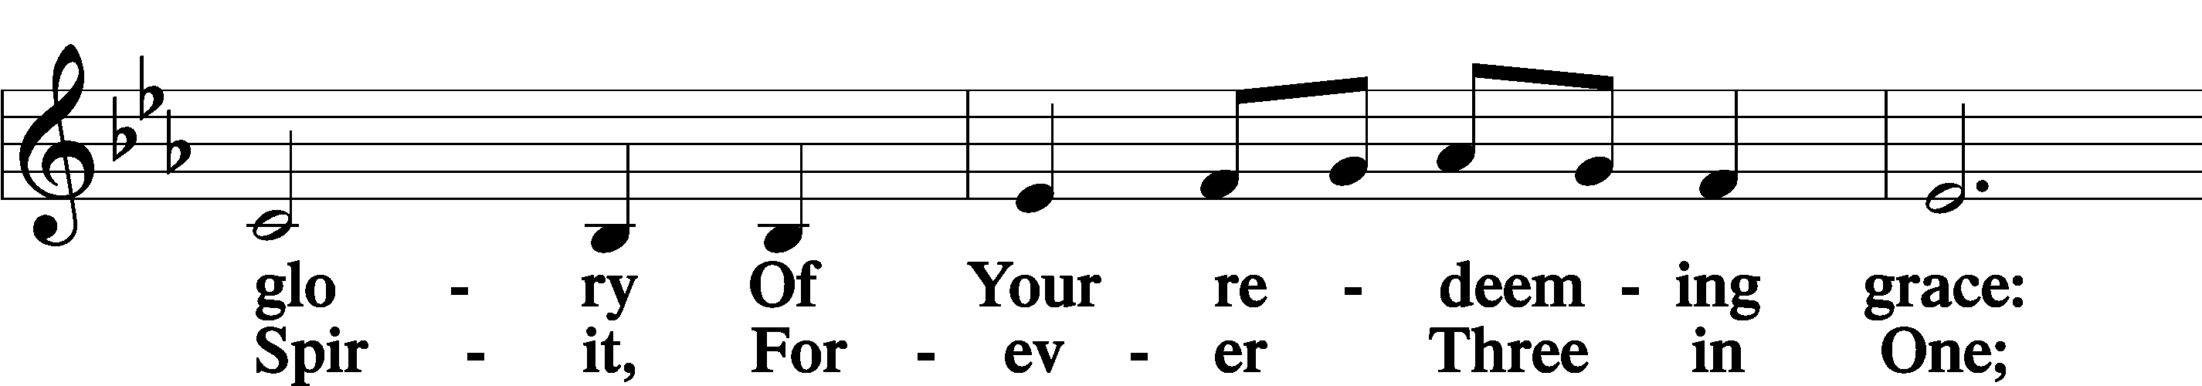
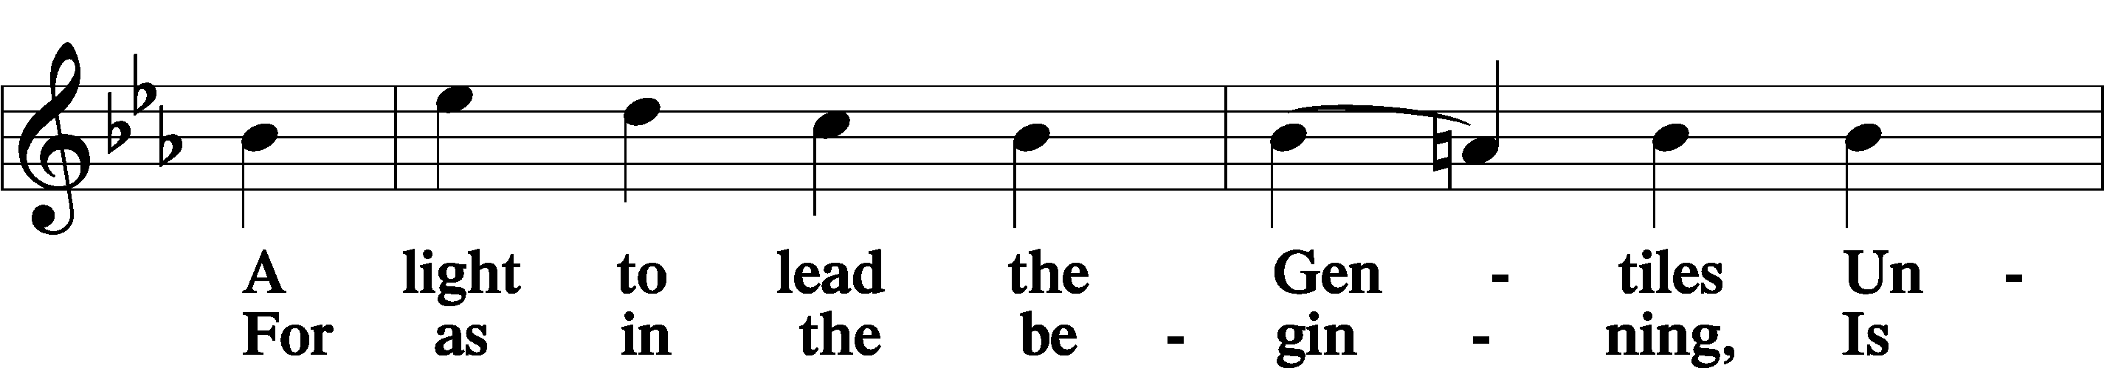
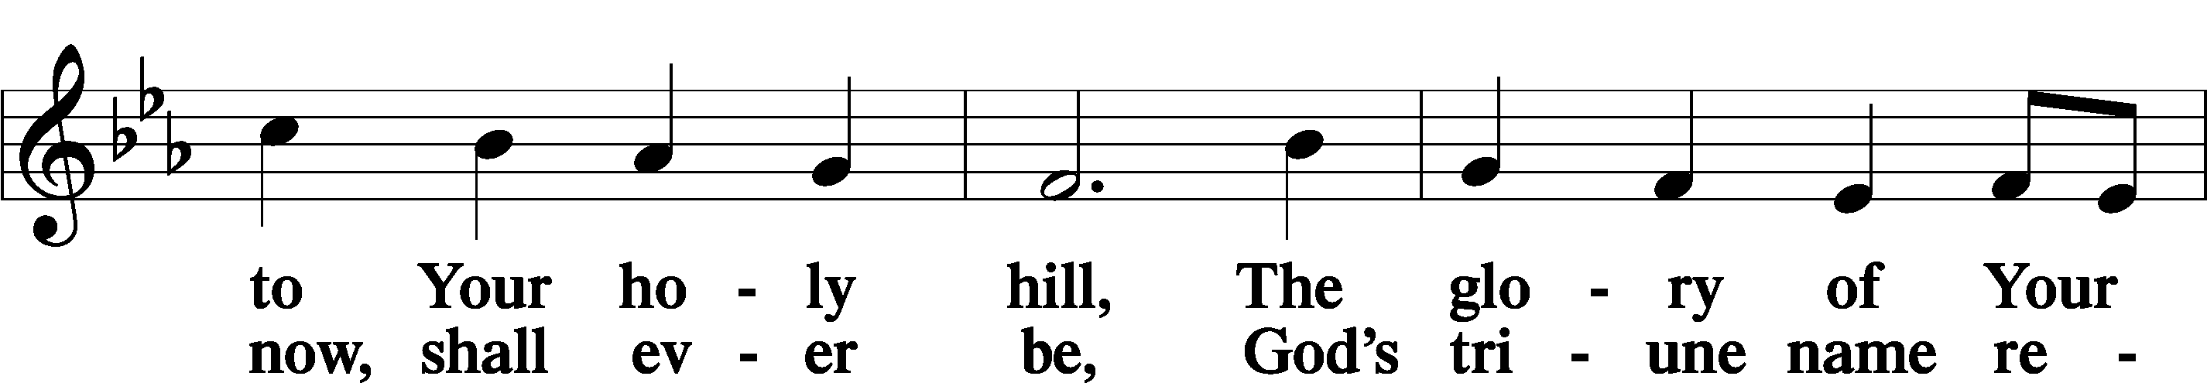
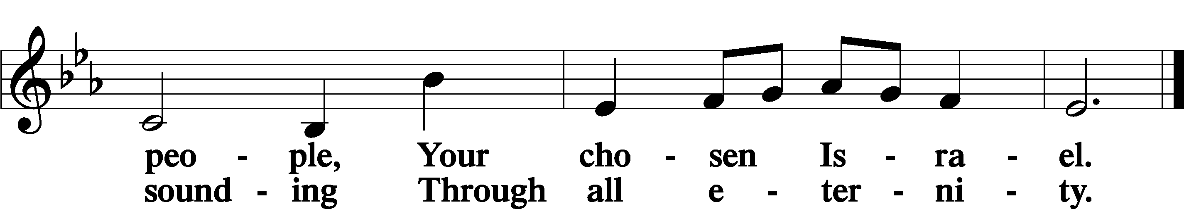

POST COMMUNION COLLECT
P Let us pray.
Gracious God, our heavenly Father, You have given us a foretaste of the feast to come in the Holy Supper of Your Son’s body and blood. Keep us firm in the true faith throughout our days of pilgrimage that, on the day of His coming, we may, together with all Your saints, celebrate the marriage feast of the Lamb in His kingdom which has no end; through Jesus Christ, Your Son, our Lord, who lives and reigns with You and the Holy Spirit, one God, now and forever.
C Amen.

BENEDICAMUS LSB 21
P Let us bless the Lord.
C Thanks be to God.

BENEDICTION
P The Lord bless you and keep you.
The Lord make His face shine on you and be gracious to you.
The Lord look upon you with favor and T give you peace.
C Amen.

Please be seated

CLOSING HYMN
We Sing for All the Unsung Saints LSB 678
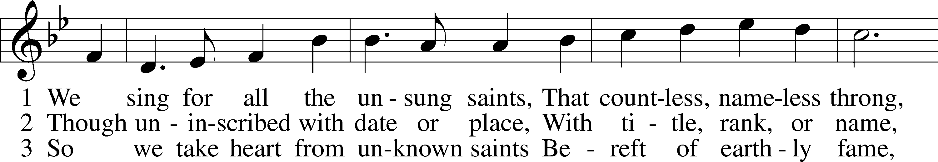
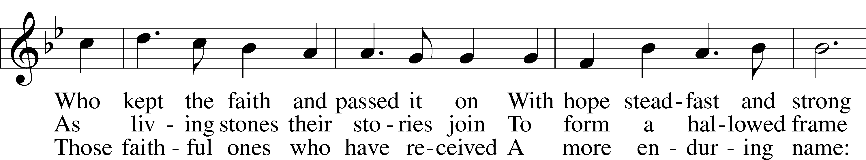
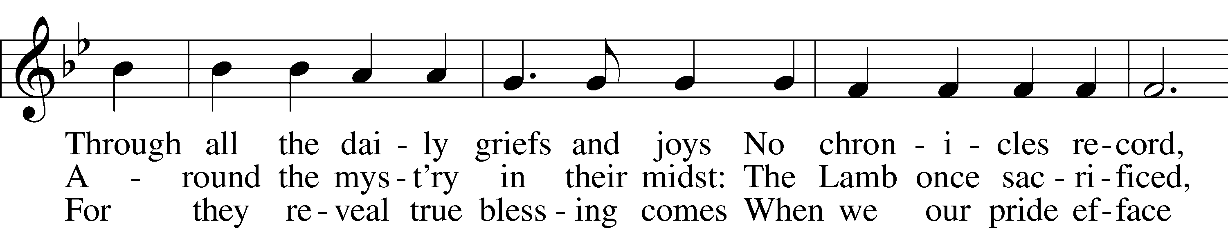
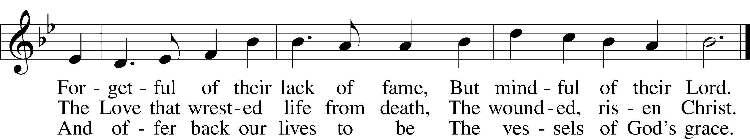

ANNOUNCEMENTS and SENDING WORDS
P We go to live for Jesus!
C We go to share His love!

Acknowledgments
Unless otherwise indicated, Scripture quotations are from the ESV® Bible (The Holy Bible, English Standard Version®), copyright 2001 by Crossway, a publishing ministry of Good News Publishers. Used by permission. All rights reserved. Created by Lutheran Service Builder. Music reproduced in this service is used with permission through: CCLI License No.1776588 and CPH – LSB Service Builder.

SERVING in GODS HOUSE TODAY
Pastor: Rev. Paul Schneider
Elder: Tim Arner
Ushers: Wally & Pam Beasinger
Greeters: Jim & Marge Kunisch
Counters: Nancy Ely, Sandy Smith
Coffee Servers :
Altar Care: Pam Beasinger
Virtual Organ: Bob Erat
Children’s Talk: Nancy Ely
Children’s Sunday School: Sharon Techel, Jean Beach and Nancy Ely
Sunday Morning Bible Study: w/ Dr. Tom Beach 10:30am
PRAYERS
Please contact the office with updates to the prayer list. People will remain on the prayer list for 4 weeks before being removed. If they need to remain on the list, please keep Elaine informed and of any updates. This will help us to have a more accurate list. Thanks for your cooperation.
Those who continue to grieve the passing of loved ones,.
Those with upcoming surgery: Greg Techel. And Bill Stiles
Those recovering from surgery: Roxy Mohr, Joann Whitney, and Jim (Joann Whitney’s brother-in-law).
Those with health concerns: Tiffany Amsdill, Wally Beasinger, Ruth Bennett (Sharron Kato’s Sister), Tanner Beyers, Hope Buchinger, Betsy Cook, Kay Gregg, Paul Kietzman, Jennifer Martin, Eleanor Raether, Beth Smith, and Judi Stutzman.
Those diagnosed with cancer: Sue Cavanagh (diagnosed with breast cancer). Leah Eicher, Rachel Frisch, Janice Knoellinger, Leslie Martin, Brian Morgan, and Hope Osantowski
Those under Hospice Home Care: Ken Williamson, Jim (Joann Whitney’s brother-in law).
BIRTHDAYS: ANNIVERSARIES;
11/7 Hope Buchinger 11/10 Vivian & Howard Weaver
11/9 Samatha Bachand
11/11 Judi Stutzman
11/11 William Wingo
11/12 Jeanine Boldrey
MESSAGES

ALTAR FLOWERS today are given to the glory of God by Judi & John Stutzman.
MEMBER & GUEST CARDS: If you have not filled out a member/guest card, please take the time to fill one out and place it in the plate behind the back pews in our sanctuary.
WEDNESDAY MORNING BIBLE STUDY, 10:00am in the fellowship hall with Pastor Ken Bernthal.
GREETING CARDS If you are in need of some greeting cards, we carry an array of them in the cabinet in the library. The cost of the cards is posted on the cabinet. The money collected from the cards goes to LWML to help support Missions.
CANCER and FRIENDS SUPPORT GROUP:. Please remember Cancer & Friends Support Group is not just for people going through treatment, or survivors, we are also here for caregiver, spouse, children, and friends. There are times when we can all use someone to talk to during those difficult times. If there is any subject you would like to discuss with me you call or text or at 989-350-4391. Hope you will join us.
ALL LADIEs OF TRINITY are invited to a soup supper and charcuterie
demonstration, on Tuesday Nov 15 at 5pm. We will enjoy delicious soups then learn about creating a charcuterie which we will make to take home. Not sure what charcuterie is? Join us on the 15th. Please sign up in the Narthex as space is limited. sponsored by LWML and Thrivent.
THANKSGIVING EVE SERVICE:: We will be having a Thanksgiving Eve Service November 23rd at 7pm.
ANGEL TREE It's that time of year again. The Angel Christmas tree will be up in the Narthex it is adorned with Angels containing the names of children just waiting for you to go Christmas shopping for them. All you have to do is take the angel with a childs name on it. When you return the gift (unwrapped) place it under the Angel tree. Gifts should be back by November 13th the latest is November 20th. Please, no food or candy. Thank you!

SERVING in GODS HOUSE NEXT SUNDAY NOVEMBER 13
Pastor: Rev. Ken Bernthal
Elder: Glenn Smith
Ushers: Linda West, Risa Sherman
Greeters: Jack & Terri Osantowski
Counters: Donna Cottrell, La Verne Scheiterlein
Coffee Servers : LWML
Organ/Keyboard: Tom & Jean Beach
Altar Care: Donna Cottrell
Children’s Talk: Nancy Ely
Children’s Sunday School: Sharon Techel, Jean Beach and Nancy Ely
Sunday Morning Bible Study: w/ Dr. Tom Beach 10:30am

THIS WEEK AT TRINITY
November 6 Sunday - All Saints Day
9:00 am Worship Service -Rev. Paul Schneider
10:00 am Fellowship & Coffee Hour
10: 10:30 am Sunday Morning Bible Study with Dr. Tom Beach
10:30 am Children’s Sunday School
November 7 Monday
10.00 am Kut-Ups
3:00 pm Open House- Learning Center.
7:00 pm Choir
November 8 Tuesday
6:30 pm Church Council
November 9 Wednesday
10:00 am Wednesday Morning Bible Study W/ Pastor Ken Bernthal
November 10 Thursday
1:00 am Ladies Guild – Fellowship Hall
7:00 pm Erats Home Bible Study Group
November 11 Friday
November 12 Saturday
November 13 Sunday
9:00 am Worship Service -Rev. Ken Bernthal
10:00 am Fellowship & Coffee Hour
10: 10:30 am Sunday Morning Bible Study with Dr. Tom Beach
10:30 am Children’s Sunday School

Please do not forget our Thanksgiving Eve Service at 7pm on
November 23rd.

